UNIT 4.4

RELATIONAL DATABASE SYSTEMS
TUTOR NAME: MS. IBTISAM MOGUL

SUBMITTED BY FATIMA EJAZ BARRI

DATABASE

DATABASE MANAGAMENT SYSTEM

ADVANTAGES OF DBMS

APPLICATIONS OF DBMS

THE THREE LEVELS OF DB ARCHITECTURE

BIG DATA

3VS OF BIG DATA

APPLICATIONS OF BIG DATA

TRANSACTION PROCESSING

FOUR PROPERTIES OF TRANSACTION WITH DIAGRAM

TRANSACTION MANAGER

DATA INTEGRITY

IMPORTANCE OF INTEGRITY

GIGO

DATA QUALITY
ENTITY RELATIONSHIP DIAGRAM-ERD
DATA DICTIONARY
NORMALIZATION

1. A) Database
A database (DB) is an organized data collection. In general, a database is an electronic system that makes it easy to access, manipulate and update data. Using a database management system (DBMS), modern databases are managed. Through relational databases such as oracle, SQL server and my SQL, etc. software programmers are acquainted with database concepts. A database structure is typically used to data in a tabular format. The architecture of the database can be external, internal or conceptual. The external level specifies how each end-user type comprehends the organisation of its relevant data in the database. The internal level is concerned with efficiency, scalability, cost and other operational issue. The conceptual level unifies the various external views perfectly into a defined an entirely global view. It consists of any generic data required by the end-user.

Database management system (DBMS)
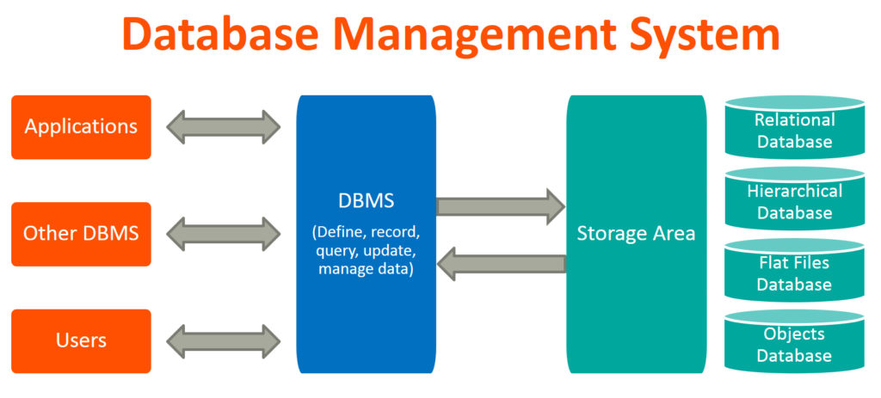
A Database Management System (DBMS) is a database management software. It is instructed by a database administrator (DBA) and therefore instructs the system to make the corresponding changes. These commands are used for loading, retrieving or modifying existing system data. A database usually requires a comprehensive database management system (DBMS) software program. A DMBS acts as an interface between the database and its end users or applications, allowing users to access, update and control the organization and optimization of the information. A DBMS also facilitates databases, monitoring, and control, enabling a variety of administrative operations such as monitoring performance, tuning, and backup and recovery.

Applications of DBMS
Banking system: to collect customer information, track day-to-day transactions of credit and debit, generate bank statements etc. with the help of database management systems all this work has been done.
Telecom: There is a database to keeps track of calls, network use, customer details etc. information. Without the database systems, the vast amount of data that keeps changing every millisecond is difficult to maintain.
Airlines: we make early reservations to travel via airlines, this reservation information is stored in the database along with the flight schedule.
Manufacturing: It is used for supply chain management and item production tracking. State of inventories in warehouses.
Educational: in schools and colleges, database systems are often used to store and retrieve data on student details, staff details, course details, examination details, attendance details, fee details etc.
Online shopping: online shopping websites like amazon, flip kart etc. need to be known. These sites store product information, addresses and preferences, credit details and provide you with the relevant product list based on your query. All this involves a system for managing the database.
https://beginnersbook.com/2015/04/database-applications/

Advantages of DBMS
The primary DMBS advantages are discussed below:
Controlling Data Redundancy:
In non-database systems, each application program has its own private files. In this case, the duplicated copies of the same data is created in many places. In DBMS, all data of an organization is integrated into a single database file. The data is recorded in only one place in the database and it is not duplicated.
Sharing of Data:
In DBMS, authorized users of the organization can share data. The database administrator manages the data and gives rights to users to access the data. Many users can be authorized to access the same piece of information simultaneously. The remote users can also share same data. Similarly, the data of same database can be shared between different application programs.
Data Consistency
By controlling the data redundancy, the data consistency is obtained. If a data item appears only once, any update to its value has to be performed only once and the updated value is immediately available to all users. If the DBMS has controlled redundancy, the database system enforces consistency.
Integration of Data
In Database management system, data in database is stored in tables. A single database contains multiple tables and relationships can be created between tables (or associated data entities). This makes easy to retrieve and update data.

Integration Constraints
Integrity constraints or consistency rules can be applied to database so that the correct data can be entered into database. The constraints may be applied to data item within a single record or the may be applied to relationships between records.

Data Security
Form is very important object of DBMS. You can create forms very easily and quickly in DBMS. Once a form is created, it can be used many times and it can be modified very easily. The created forms are also saved along with database and behave like a software component. A form provides very easy way (user-friendly) to enter data into database, edit data and display data from database. The non-technical users can also perform various operations on database through forms without going into technical details of a database.
Report Writers
Most of the DBMSs provide the report writer tools used to create reports. The users can create very easily and quickly. Once a report is created, it can be used may times and it can be modified very easily. The created reports are also saved along with database and behave like a software component.

Control Over Concurrency
In a computer file-based system, if two users are allowed to access data simultaneously, it is possible that they will interfere with each other. For example, if both users attempt to perform update operation on the same record, then one may overwrite the values recorded by the other. Most database management systems have sub-systems to control the concurrency so that transactions are always recorded with accuracy.

Backup and Recovery Procedures
In a computer file-based system, the user creates the backup of data regularly to protect the valuable data from damage due to failures to the computer system or application program. It is very time consuming method, if amount of data is large. Most of the DBMSs provide the 'backup and recovery' sub-systems that automatically create the backup of data and restore data if required.
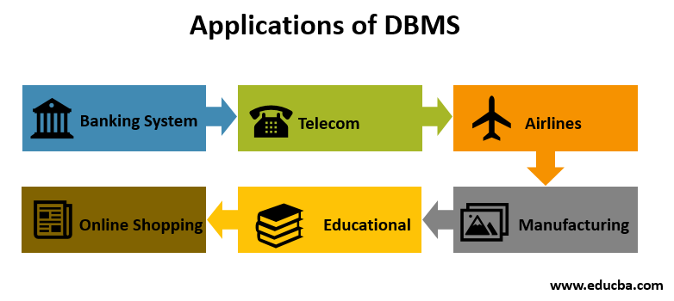

Data Independence
The separation of data structure of database from the application program that uses the data is called data independence. In DBMS, you can easily change the structure of database without modifying the application program.
- Schema and Instance
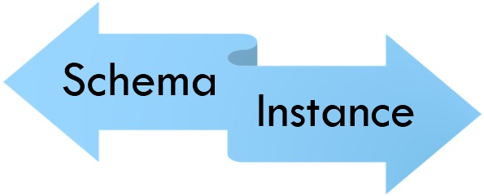

Schema:
It is the overall description of the database. Database administrator (DBA) is the person who has central control over the database (data as well as programs).schema is the logical view of database for database administrator.
There are two main kinds of database schema:
- Physical schema: it is the ability to modify the physical details without affecting the logical schema.it is provided by the mapping of DBMS & operating system.
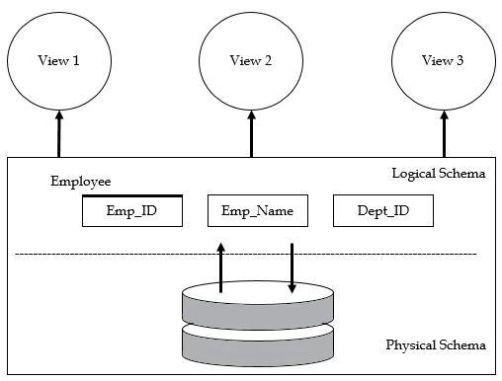
- Logical schema: it is the ability to modify the logical schema without causing applications programs to be rewritten. In addition, the changes in view level should not cause changes in schema.

Example of database:
Conceptual schema:
- Students (Sid: string, name: string, login: string, age: integer)
- Courses(cid: string, cname: string, credits: integer)
- Enrolled(Sid: string, cid:string,grade:string)
Physical schema:
- Relations stored as unordered files.
- Index on first column of students.
External schema (view):
- Course info (cid:strin,enrollment:integer)

1.b) Three levels of database structure architecture

1.c) BIG DATA

3 VS velocity variety volume

Applications of Big data

1.d) Transaction

Transaction properties (ACID)

Transaction state

Diagram

Transaction manger Diagram

OLTP

OLAP

Difference between OLAP and OLTP

1.e)

GiGO

Data integrity definition

Integrity importance

Data quality

Task 2:

Define Database Design

Entity relationship diagram Define

https://www.techopedia.com/definition/1185/database-db

